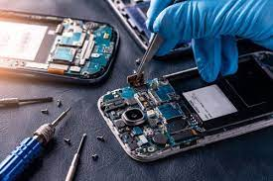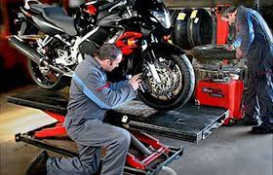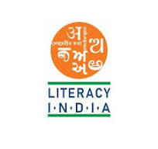...

Programs Offered

* Robotics /Tinkering
* Computer hardware
* Mobile Repairing
* Cooking /Hospitality
* Beauty and Wellness
* Stitching and Cutting
* Electrical troubleshooting
* Two wheeler repairing
* Mobile journalism
* Computer science
* Data digitization

Literacy India Community College (LICC)

**Register Now**

www. Literacyindia .org

Session Starts From

January 2024

**Contact no. 8588853380**





Limited seats